Created IMDB database using
Create Database IMDB;

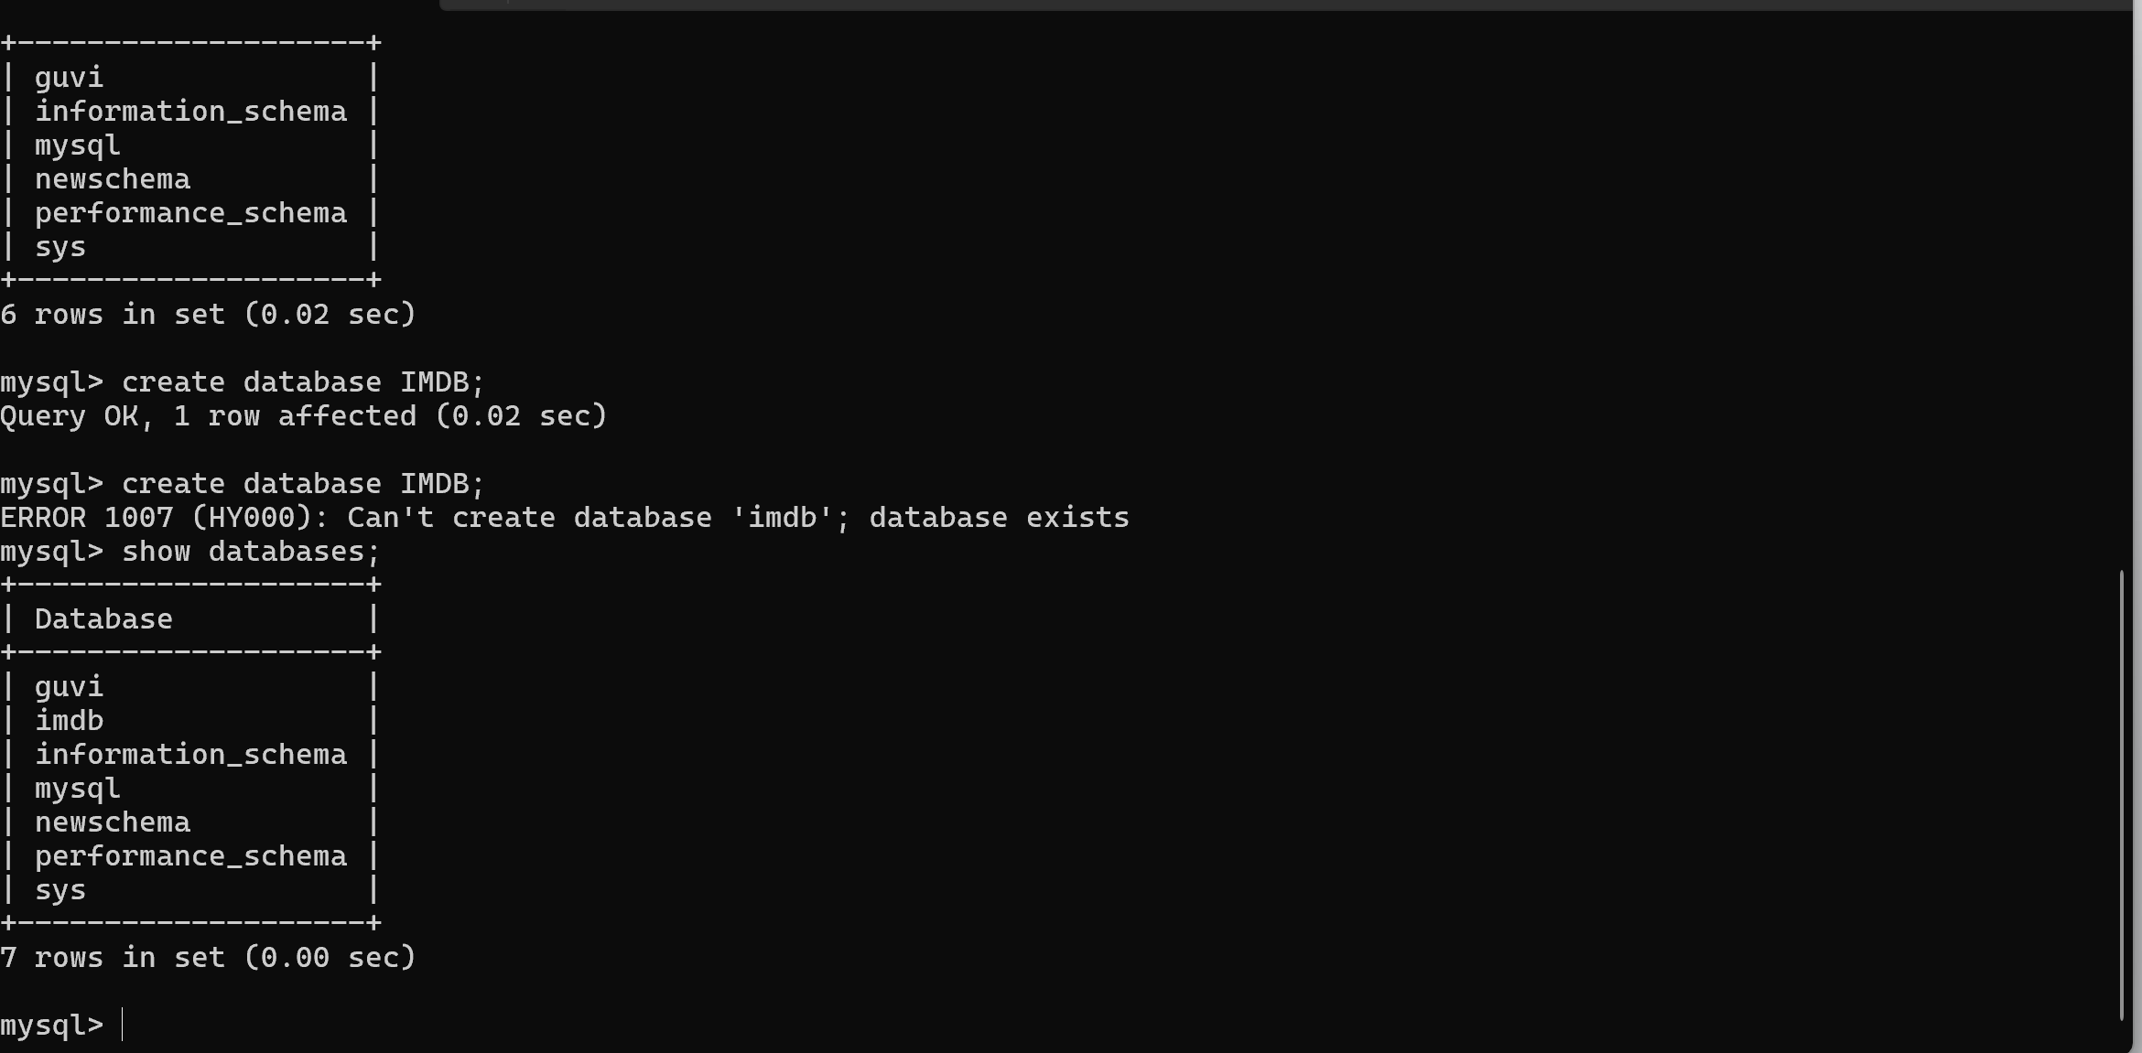

To list the tables in Database use commands,
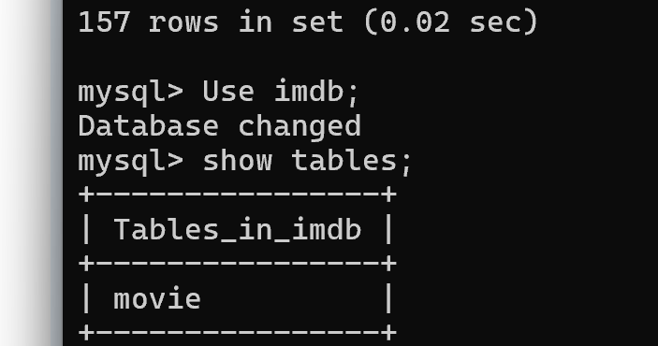
Step 2: Creating table movie , Artist, Review and Audit in DB IMDB.

Movie Table:
Creation DDL(Data Definition language – shows the query how the table is created):
create table imdb.movie
(movie_id bigint, movie_name varchar(200),
video_image_reference varchar(200), typeOfmovie varchar(10),
artist_name varchar(100), language varchar(25),
duration timestamp, genere varchar(20),
primary key (movie_id)) ;
Primary key : is a column in a table when a column is specified as primary key that allow duplicates and null value in order to make the entire unique from the rest of the column
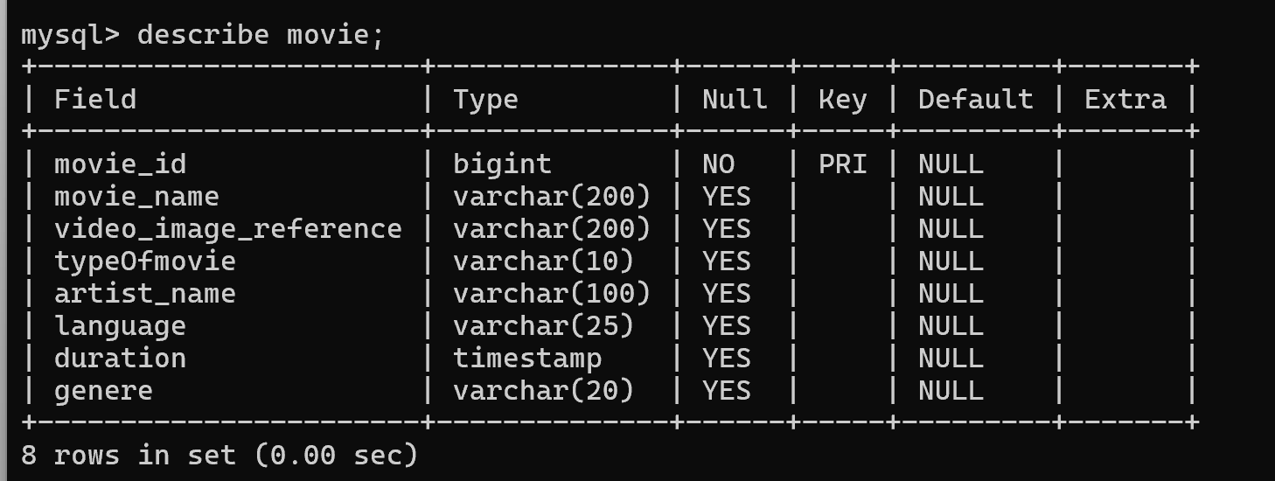

Create Artist table:
(DDL for artist table)
create table artist
(artist_reg_id int, artist_name varchar(100),
artist_salary bigInt, is_new BIT, artist_experience int,
movie_name varchar(200),
primary key (artist_reg_id),
foreign key (movie_name) references movie(movie_name));

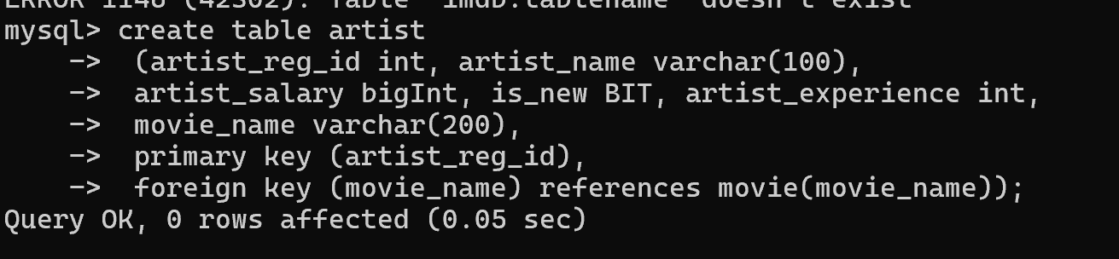

Foreign key: is a reference key for two or more table when they have same column used. And this will be a primary key in one table and foreign key in other table.
Before incorporating some key as foreign key the table for foreign key should be created.
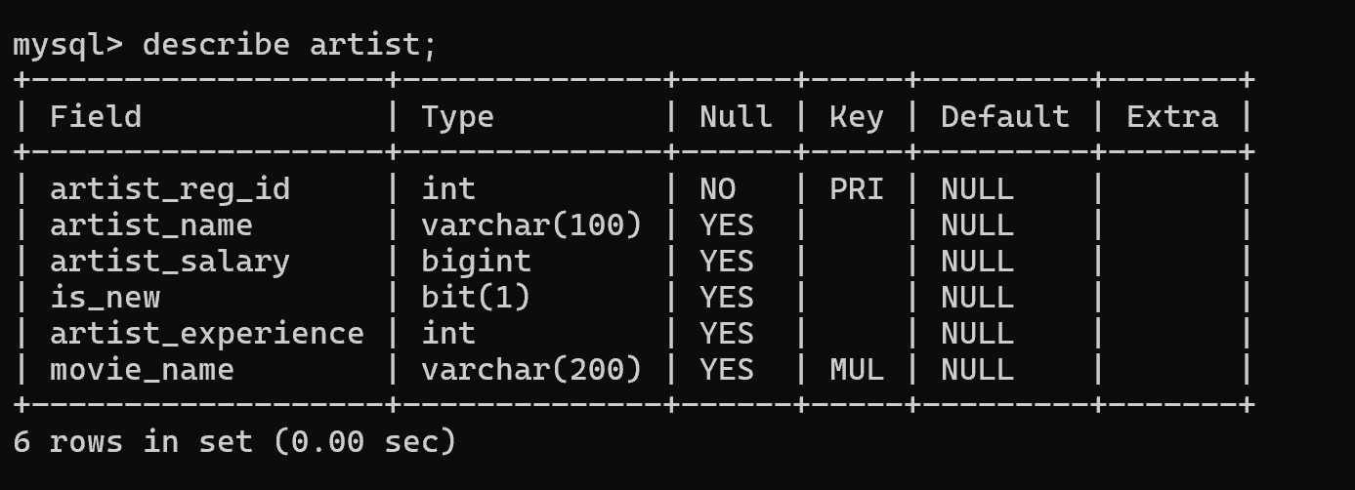

Insert value into table using:
Syntax:
Insert into tablename values(column1 value, column 2 value………,)

Insert into imdb.movie
values(00001236, "upload",
"martin_birth.mp4", "kids",
"Pitsburgh", "English",
'2025-11-05 14:30:00', "comedy"),
(00001237, "thalapathy",
"THee_intro_scene_ref.avi", "U/A",
"Rajini", "tamil",
'1991-11-05 12:30:00', "family");

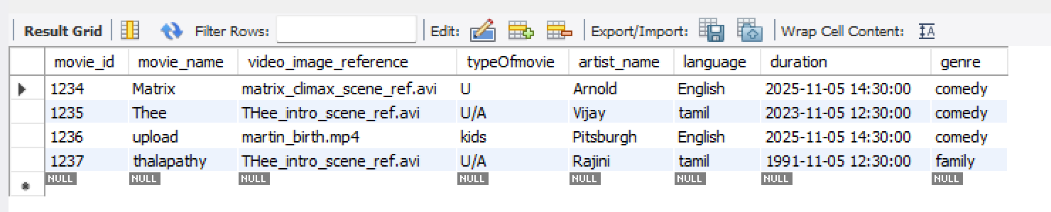

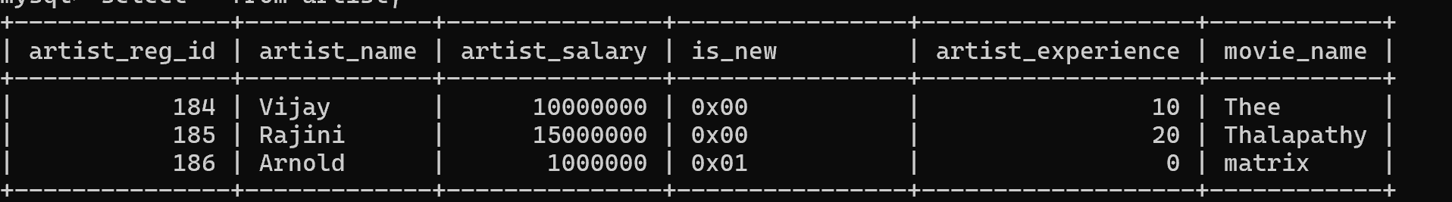

Rename a column:
Syntax :
Alter table tablename rename column oldname to newname
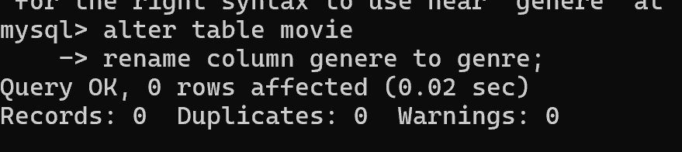
Then check using command.
Describe tablename;
Group By: Group by is used along with aggregate function where aggregate functions like count(),avg(),sum(),min(),max().
Execution order: from -> where ->,group by -> having -> select -> order by

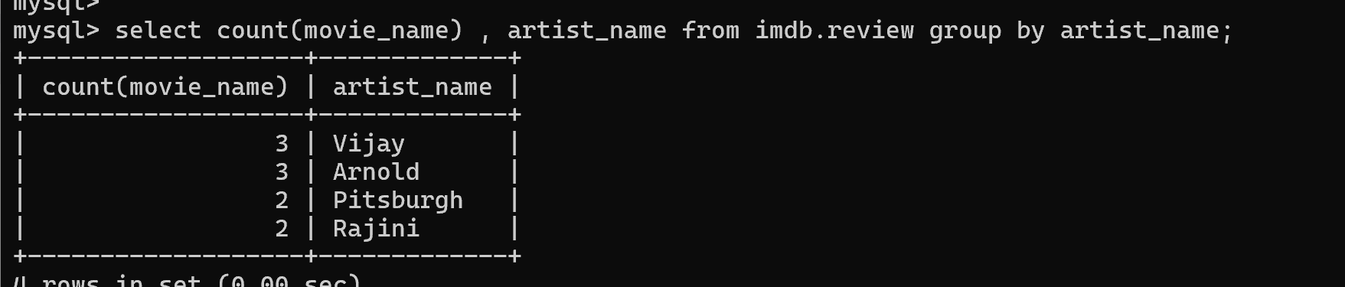

Having() is used to filter along with group by :
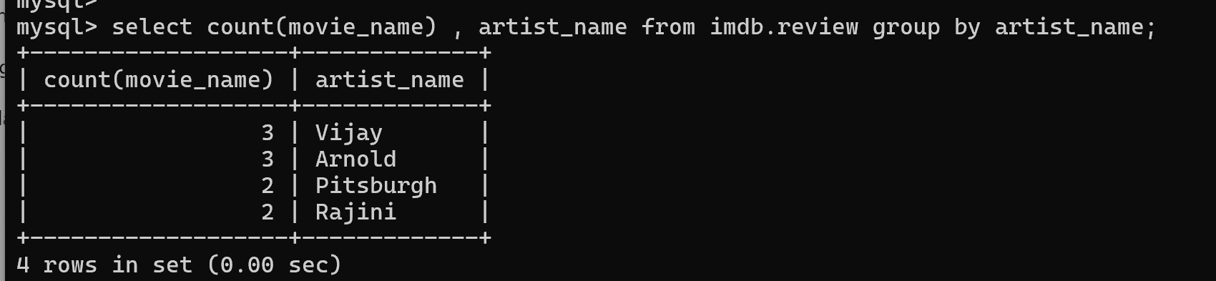
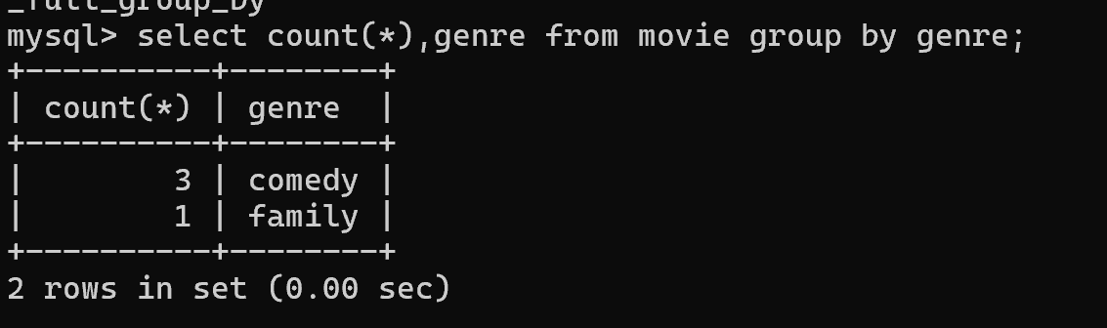

SET Usage: Set command is used to update the column values.
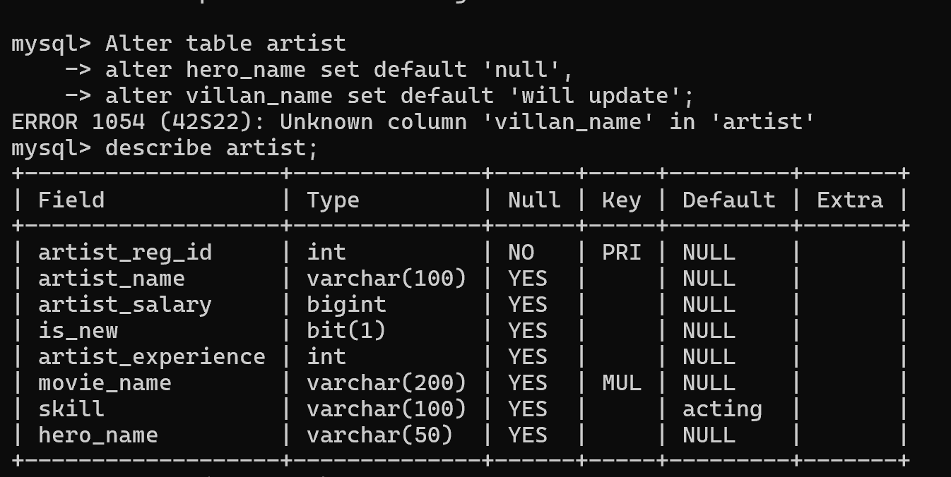

Order By:
Order by is used to sort the rows based on column if in general we give order by some field it will sort alphabetically in ascending way.

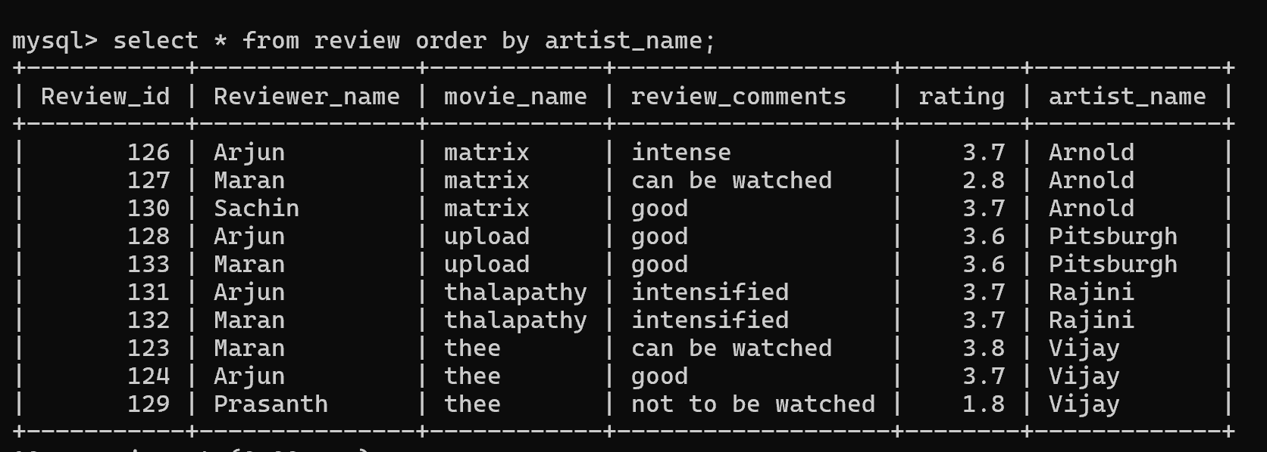
In order to sort descending way use desc after order by column name.
select * from review order by artist_name desc;
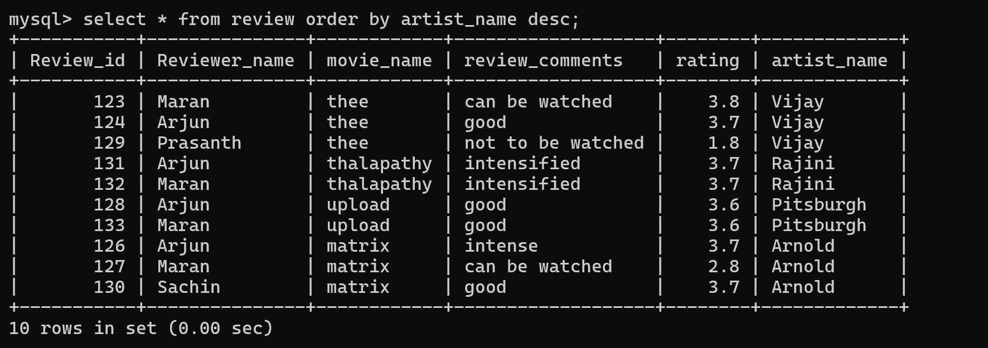

Where : where keyword is used to filter out based on specific condition
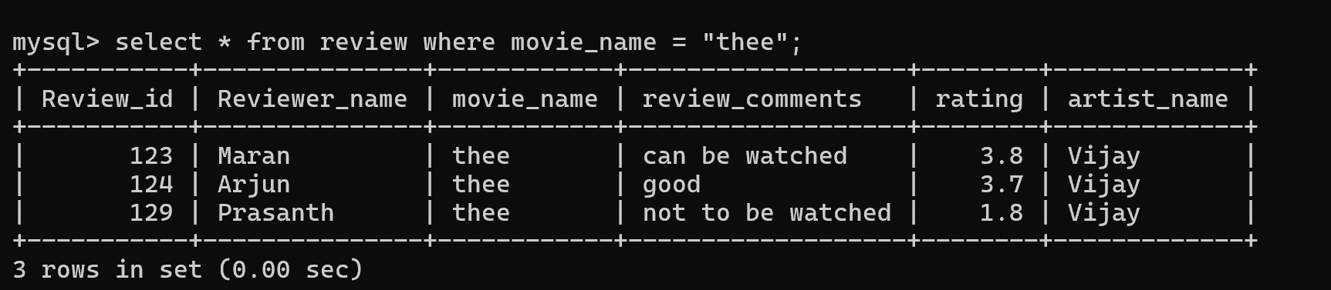
We can use AND , OR in order to apply multiple condition.
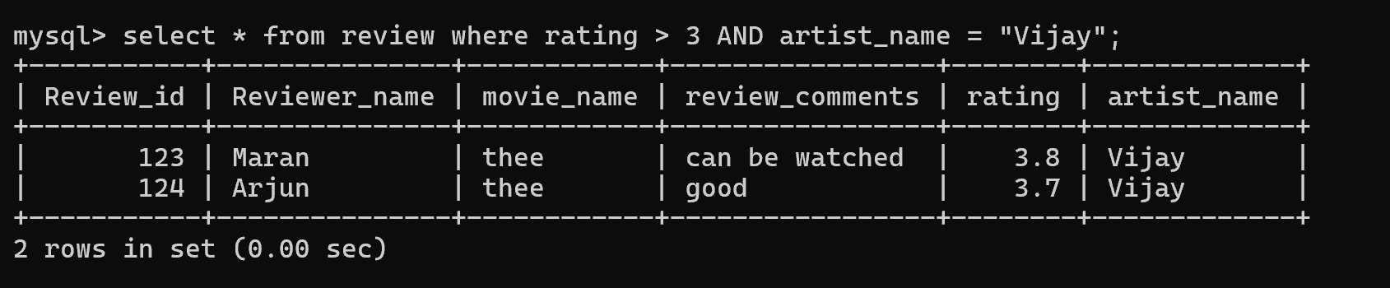
Create Index:
Index are constraints or rule if it is created for certain column and when we use the index in select query the search will be faster
Create index indexname on tablename(columnname1, columnname2)

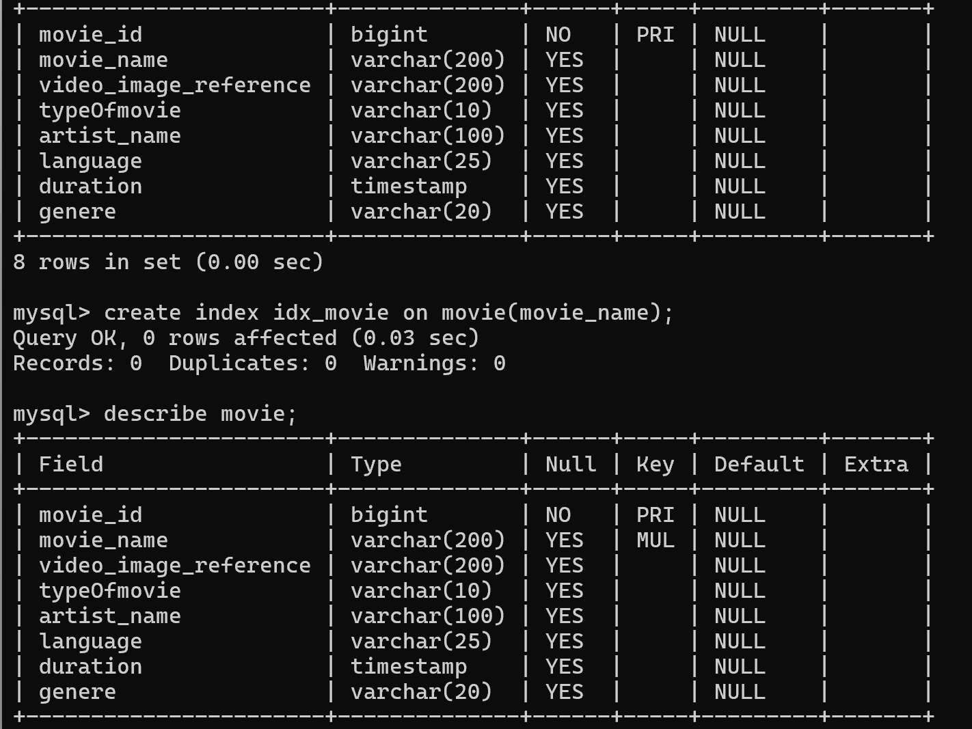
Drop table :
Drop table tablename;
Drop table imdb.movie;

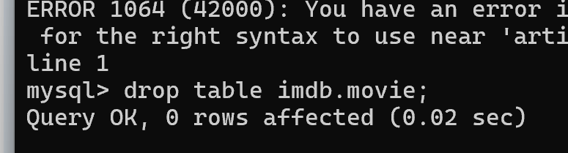
To check whether the table removed or not then check using
Select * from tablename;
Select * from imdb.movie;

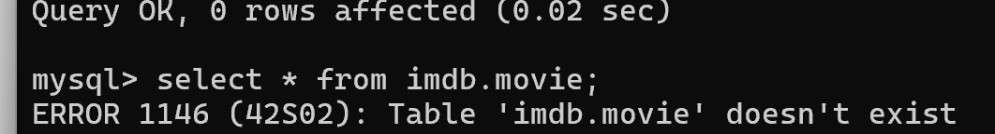

SubQuery: Subquery is nested query where in output of one query forms the input for the other.

Select genre from movie where in(select movie_name from review where rating <3);
